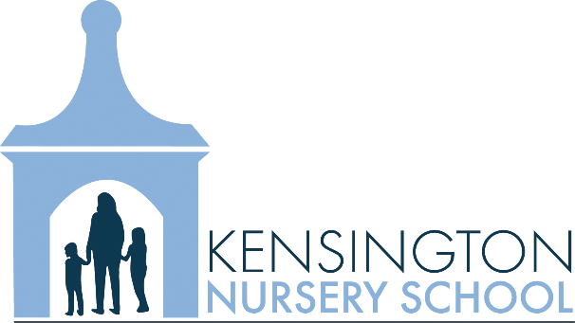
  - Hiring Part Time Preschool Teacher’s Aide
APPLY NOW!
  - KNS, a family centered preschool, is immediately seeking a part-time teacher’s aide for Monday, Wednesday and Friday. Candidates must have some experience working with preschool age children, early childhood education is favorable, but not required. Applications are available at www.kensingtonnurseryschool.org. Applications must be received by October 5, 2017.

