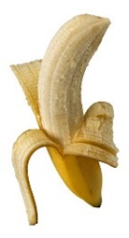
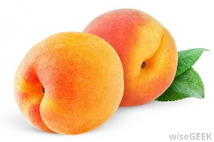
Snack Time in Our 2 Day Preschool Class

Allergies: KNS is a NUT-FREE school! Please NO peanut butter or tree nuts! This year we have a child who is allergic to milk, eggs & butter. Please try to be mindful of this when you make your snack choices.
Information: Snack Time allows for the children to experience new snack choices, to practice spreading and cutting with a plastic knife, and, most importantly, practicing their manners. “Please” and “Thank you” should be frequently heard and used as the children are encouraged to pass items amongst themselves and their teachers. The children will need to ask to please be excused from their tables upon completion of their snack. They are responsible for cleaning up their own area including disposal of their trash.
The working parent supplies snack and drink for the entire class and we kindly ask that you supply 2 healthy choices. Alternative snacks free of milk, eggs and butter will be available in the classroom for the child with the allergy in the event you are not able to provide such a snack. If we are celebrating your child’s birthday, a sweet treat is fine, but please consider offering something healthy as the 2nd choice. (For example, donut holes with strawberries.) Plastic silverware, cups and napkins are available at the school for snack time use.
Please remember the children are small so portions do not have to be large! Pre-packaged items are generally more than they can eat. Family style serving is best as we can control the portions served.
Please remember to record your snack and juice on the Snack Sign-In Sheet. Kindly check the sheet to see what has been brought in prior to your snack day. The children get tired of the same thing over and over again!
(See reverse side for healthy snack ideas!)

Healthy Snack Ideas
(These are all milk, egg and butter free!)
(Just suggestions! You are not limited to these!)
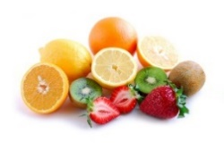
Fruits/Veggies Grains
Apple slices Graham Crackers
Applesauce Triscuits or Wheat Thins
Oranges Cheerios Dark Chocolate Crunch
Grapes Cinnamon Life cereal
Fruit cups Animal Crackers
Cucumber slices Rold Gold Plain Pretzels
Pepper strips Honey Maid Dippers
Strawberries Golden Grahams Cereal
Pineapple Teddy Grahams
Bananas Skinny Pop Plain Popcorn
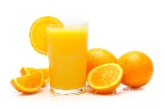
Pepperidge Farms Plain Goldfish (not cheese)
Ritz Crackers
Extras Drinks
Jam for crackers 100% Juices
Lemonade
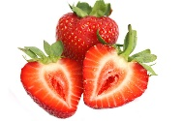
(Water is always available at snack time!)

